
denise shannon literary agency inc

FRANKFURT BOOK FAIR 2018

Foreign rights to titles described below are controlled by DSLA and its co-agents.

Darcey Bell A SIMPLE FAVOR (Harper)
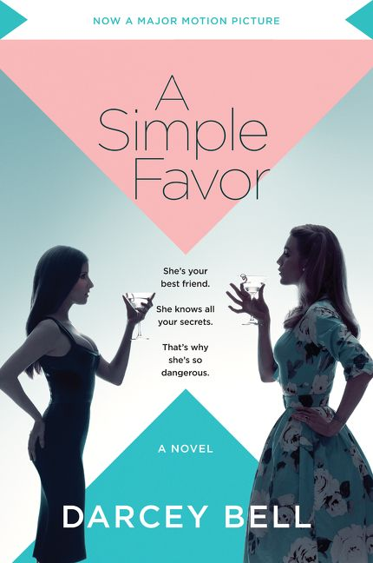
**NYT Bestseller with over 240,000 copies in print**
** Feature Film is in wide release worldwide
starring Anna Kendrick, Blake Lively, and Henry Golding**
This domestic thriller has been an international success (25 foreign sales), and now the film promises to be one, too. Directed by Paul Feig (best known for his female-centric comedies BRIDESMAIDS and GHOSTBUSTERS). The film is being hailed as “a clever, knotty, and sporadically sexy thriller” (Variety) and “a taut, absorbing, divinely chic ride” (EW).

HarperCollins released two movie tie-in editions (trade paperback and mass market), and both editions are hitting bestseller lists.
Movie Tie-in publication Date: August 2018

Foreign rights sold: Pan Macmillan/UK, Bertrand/Portuguese (Brazil), Rizzoli/Italian, Prometheus/Dutch, Vulkan/Serbian, HarperCollins/German, G.E.C Gads Forlag A.S/Danish, Dogan Egmont/Turkish, Hugo & Cie/French, Klidarithmos Publications/Greek, Citic Publishing Group/Chinese (simple), Świat Książki/Polish, AST License Limited/Russian, Leda Spol/Czech, Gabo Kiado/Hungarian, Hayakawa Shobo/Japanese, Hyeonamsa Publishing/Korean, Penguin Random House/Spanish, Hemiro Limited/Ukrainian, Delight Press/Complex Chinese (Taiwan), Grup Media Litera/Romanian, Bertrand/Portuguese (Portugal), IKAR A.S./Slovak, La Campana/Catalan and Tammerraamat/Estonian

Chanelle Benz THE GONE DEAD (Ecco)
An electrifying first novel from "a riveting new voice in American fiction" (George Saunders): A young woman returns to her childhood home in the American South and uncovers secrets about her father's life and death….Billie James’ inheritance isn’t much: a little money and a shack in the Mississippi Delta. The house once belonged to her father,

a renowned black poet who died unexpectedly when Billie was four years old. Though Billie was there when the accident happened, she has no memory of that day—and she hasn't been back to the South since. Thirty years later, Billie returns but her father's home is unnervingly secluded: her only neighbors are the McGees, the family whose history has been entangled with hers since the days of slavery. As Billie encounters the locals, she hears a strange rumor: that she herself went missing on the day her father died. As the mystery intensifies, she finds out that this forgotten piece of her past could put her in danger. Inventive, gritty, and openhearted, The Gone Dead is an astonishing debut novel about race, justice, and memory that lays bare the long-concealed wounds of a family and a country. Benz was born in London and now lives in Memphis, TN.
Publication Date: May 2019

Foreign rights sold: Éditions du Seuil/French

Carrie Blake THE WOMAN BEFORE YOU (Impulse/Harper UK for World English)

A debut novel of psychological suspense with a very sexy relationship at its center. Yes, it’s commercial, but it’s super fun to read, clever and well-written (for example the book refers to the myth of Orpheus and Eurydice, to the Borgias, and to de Kooning). Isabel, a wannabe actress, turns to the dating app Tinder for a new role in her own life, making the First Date into theater. It's innocent but fun to turn herself into wildly different characters, until she matches with Matthew, whose Manhattan real estate power player boss, Val Morton, seems to be running Matthew’s life. When Isabel invites Matthew to play along, the roles flip, and she’s no longer in charge, becoming an all-too-willing participant in the subsequent sex games and challenges that Matthew devises. When Matthew gives her one final role to play, their erotic games turn criminal, and the two puppets in this sexual theater become embroiled in a power struggle that is larger than either can handle.

Publication Date: April 2018

Foreign rights sold: Burda/Polish, Ediciones B/Penguin Random House/Spain

Lydia Davis ESSAYS I (Farrar, Straus & Giroux)
“The Impetus Was Joy” is the title of one essay in this book, the first nonfiction collection from Man Booker International Prize winner Lydia Davis. She conveys her joyful enthusiasm for language and unconventional narrative strategies of writers who have inspired her: Beckett, Paley and Pynchon, among others. She writes more about other writers than herself, still it’s unusual to read someone who is so unguarded about her process, as she reveals how she conceives, writes and rewrites a few of her own stories. In a recent profile, The New Yorker wrote that she is “widely considered one of the most original minds in American fiction today.” This offers a journey into her fastidious mind. Publication will be September 2019.

Delivery Date: November 2018

Foreign rights sold: Atlas Contact/Dutch, Hamish Hamilton/UK

Foreign rights to CAN’T AND WON’T (2014) sold: Forlaget Vandkunsten/Danish, Atlas Contact/Dutch, Hamish Hamilton/UK, Droschl/German, Cappelen Damm/Norwegian, Relogio d’Agua/Portuguese (Portugal), Munhakdongne/Korean, RCS BUR/Italian, Editora Schwarcz/Portuguese (Brazil), Edicions del 1984 Publishing House/Catalan, Eterna Cadencia Editora/Spanish, Editions Christian Bourgois/French, Sekwa/Swedish, Geopoetika/Serbian, Tekrar Yayincilik/Turkish, Chu Chen/Chinese (simple), Ofoq Publishers/Farsi, Ink/Complex Chinese (Taiwan), Oceanmore/Croatia.

Aryn Kyle HINTERLAND (Riverhead)
Following Aryn Kyle's bestselling and highly-acclaimed debut novel THE GOD OF ANIMALS, her next novel, HINTERLAND, is a story of intense, platonic friendship between two adults, a young man and young woman, and the shocking ways it shapes their lives—even long after the friendship has ended. Peter and Wyatt meet in college when they are both aspiring playwrights. Only one of them will go on to real critical, professional success; only one of them will start a family: their lives post-college do not follow the matching paths they might once have imagined. But the roots of their friendship are deep, and over the years, even when they are no longer in touch, memories of their bond will inform many of their biggest decisions. So when Wyatt suddenly dies in her 40s, it is an event Peter believes he could have saved her from. Her death will further change the course of his life, and inadvertently reconnect him with his estranged teenage daughter.
Delivery date: November 2018

Foreign rights to THE GOD OF ANIMALS (2007) sold: Rizzoli/Italian, Weidenfeld & Nicolson/English in UK, Nieuw Amsterdam/Dutch, Gallimard/French, Goldmann/German, Ecus/Complex Chinese (Taiwan), Editora Rocco Ltda/Portuguese (Brazil), Shanghai 99/Chinese (simple), Olympia/Czech, Munhakdonge/Korean, Smak Slowa/Polish, Mehta Publishing/Marathi, Ediciones Ámbar/Spanish, and Aletheia/Portuguese (Portugal)

Ben Marcus NOTES FROM THE FOG: STORIES (Knopf)
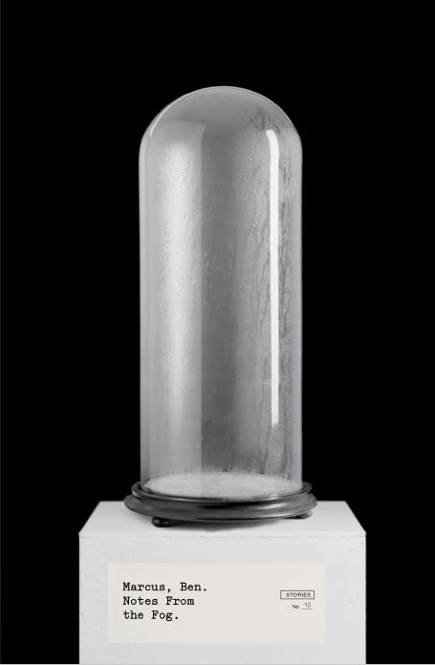
“Intellectual brilliance… A book than can create such a visceral response is a rare thing indeed. These stories have that roller-coaster sense of both excitement and nausea” – The Scotsman

Marcus is considered one of the most inimitable, essential writers working today. This is a beautiful collection that showcases his compassion, tenderness and mordant humor. In these 13 ingenious stories, he reveals moments of redemption in the sometimes nightmarish modern world. In the chilling “Cold Little Bird,” a father finds himself alienated from his family when he starts to suspect that his son’s precocity has turned sinister. “The Boys” follows a woman who descends into an affair with her recently widowed brother-in law. In “Blueprints for St. Louis” two architects in a flailing marriage consider the ethics of adding a mist that artificially incites emotion in mourners to their latest assignment, a memorial to a terrorist attack. Blistering, beautiful, urgent work from a true modern master.

Publication Date: August 2018

Foreign rights sold: Granta/UK, Hoffmann & Campe/German

James Oseland JIMMY NEUROSIS: A MEMOIR (HarperCollins)
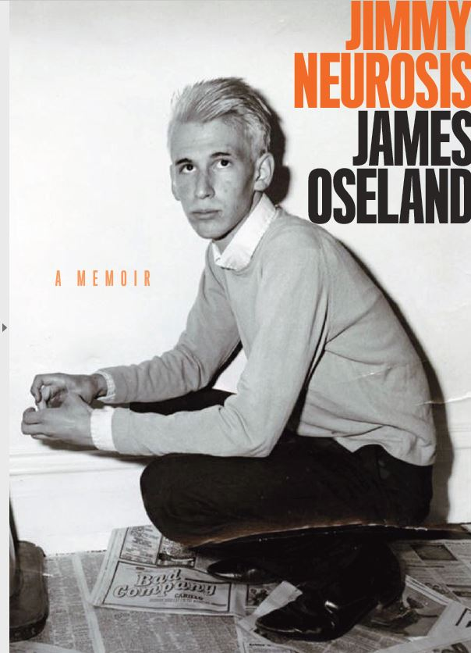
James Oseland, the former editor of Saveur Magazine, has a searing story to tell. Set against the backdrop of American punk rock history, this memoir chronicles the most painful, turbulent, and ecstatic years of his life. After the breakup of his seemingly perfect middle-class family, James becomes Jimmy Neurosis: a high school dropout, drug addict, and punk rocker. Similar in spirit to JUST KIDS and PLEASE KILL ME, this is the story of the birth of the individual creative soul, and the man who discovers the threads that led him to become an award-winning editor and culinary figure.

Delivery date: February 2019

Miranda Popkey TOPICS OF CONVERSATION (Knopf)
This debut novel moves effortlessly from quietly hilarious to skewering to gorgeous and lyrical. The narrator is a young single mother in California, and the novel unfolds through a series of conversations the central character is having and explores the nature of truth, female pain, desire, and subjectivity. The voice is knowing, somewhat cynical, funny and playful. This book will establish Miranda Popkey as a distinctly contemporary literary voice. Popkey is a former associate editor at FSG. Her articles and essays have appeared in the New Yorker, Harper’s, and GQ. Publication will be in Spring 2020.

Delivery date: November 2018

Kirstin Valdez Quade NIGHT AT THE FIESTAS: STORIES (W.W. Norton)
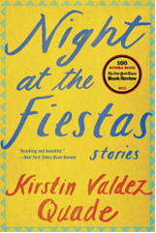
This collection has won practically every first book prize that exists, the Sue Kaufman Prize for First Fiction, the NBCC’s John Leonard Award for a debut book, and the National Book Foundation’s 5 Under 35 for emerging fiction writers. The book was also one of NYTBR Notable Books. In a rave review, The Atlantic noted that “Quade goes for vivid spectacle and theatrical plot twists,” and NYTBR praised it as “a variety of beauty too rare in contemporary literature.…. The collection reminds us, again and again, that each of us has only one life, and forces us to confront the biggest questions.”

Valdez Quade was a Wallace Stegner Fellow at Stanford University, and she is currently Assistant Professor at Princeton University.

Publication date: February 2015

Kirstin Valdez Quade UNTITLED NOVEL (W.W. Norton)
Quade's first novel is an expansion of her much-praised New Yorker story, "The Five Wounds." It opens during Semana Santa (Passion Week) in a small town in northern New Mexico. Amadeo Padilla has been given the part of Jesus in the Passion procession, and he is preparing for this role, which he believes will redeem him and transform his life, when his pregnant fourteen-year-old daughter Angel shows up on his doorstep. It is an exploration of the painful complexities of family obligation and is inspired by the work of writers such as Alice Munro and Antonya Nelson. Written in alternating third-person points of view, it is not a book about faith as much as it is a book about surviving, with characters discovering that their pasts can be a source of both destructive pain and also great sustenance and that the binds of family are not a birthright but must be constantly made anew.

Delivery date: September 2018

Hugh Raffles NORTH: Rocks, Stones and Other Elemental Things (Pantheon)
From the author of the widely-acclaimed INSECTOPEDIA comes NORTH. Weaving together memoir, history, and geology in a mesmerizing and affecting narrative, Hugh Raffles takes readers on an unforgettable journey through eight northern landscapes that in different ways reveal the profound absences that shape our present. NORTH documents Raffles’ investigations of loss, disappearance, and the worlds that endure. In a series of lyrical and unexpected essays, he explores the death of his sister in the Outer Hebrides, the extermination of whales in Svalbard, the displacement of Native Americans from the northern United States, the transport of Inuit and meteorites from Greenland, and the life and afterlife of his great-aunt deported north from Berlin to the Nazi camp at Theresienstadt. A deeply-researched meditation on place and time, a book that shows how everything new is riven with the shards of history.

Delivery Date: December 2018

Praise for INSECTOPEDIA:
“As inventive and wide ranging and full of astonishing surprises as the vast insect world itself. Raffles takes us on a delirious journey, zooming in and out from the microscopic to the global, from the titillating to the profound, from Niger to China, from one square mile above Louisiana to the recesses of his own mind.” (The New York Times)

“[A] big, beautiful testament to the glory of paying attention.” (Anthony Doerr, The Boston Globe)

Jess Row WHITE FLIGHTS: RACE, FICTION, AND THE AMERICAN IMAGINATION (Graywolf Press)
Jess Row, a 2016 Guggenheim fellow and Granta’s “Best Young American Novelist”, has just finished a collection of critical essays exploring the subject of race in American fiction and culture. Following in the success of his novel YOUR FACE IN MINE (Riverhead Books, 2014), WHITE FLIGHTS confronts the issues of what “whiteness” means in 21st century literature: how white writers have ignored race in their writings for years, and what the future holds for a post-racial literary landscape.“These are brilliant, sweeping, intimate delights—and afterward, you may never read the same way again.”—Alexander Chee

Publication date: August 2019

Jess Row THE NEW EARTH (Ecco)
Jess Row's second novel, THE NEW EARTH, is about a fractured Manhattan family of eccentrics, intellectuals and spiritual seekers who reunite for the wedding of their only living daughter, an immigration lawyer, to an undocumented immigrant from Chiapas. The novel has many strands—from Holocaust art to the Zapatistas, from Buddhist logic to American immigrant law, climate change to the sensibility of northeastern liberals. Like THE CORRECTIONS or Norman Rush’s MORTALS, the author combines narrative drive with a sense of expansive, inclusive curiosity, but the book will also be one that steps outside the single, privileged authorial consciousness that dominates those novels. What he’s hoping to create is a novel that feels balanced between an accretion of old wounds, resentments, and histories and a sense of radically new possibility that lies outside the imagination of this very analytic, intellectual, privileged family—a novel that is intimately connected to its central characters but also aware of what they can’t (or won’t) see, about themselves and about the world.
Delivery date: December 2018

Karen Russell ORANGE WORLD: Stories (Knopf)
A MacArthur Fellowship (genius award) recipient and Pulitzer Finalist, Karen Russell creates fantastical worlds that hum with recognizable rhythms. Her previous books (the novel SWAMPLANDIA! and story collections ST LUCY’S HOME FOR GIRLS RAISED BY WOLVES and VAMPIRES IN THE LEMON GROVE) were published to both critical and commercial success. In ORANGE WORLD, we have a new collection of world-building stories. Critics have called her “One of the great American writers of our young century” (NPR) and her work “heartbreakingly vulnerable and keenly emotional… a tour de force.” (Elle).

Publication date: June 2019

Karen Russell SLEEP DONATION (Vintage Originals)

Vintage will be publishing a souped-up version of her short novel that was initially published only digitally in 2014. Despite no print edition, it managed to get raves from NYT, LA Times, Entertainment Weekly, NPR and many others. In SLEEP DONATION, set in a dystopian near future, a lethal plague of insomnia is spreading through the overstimulated, anxious population, leaving thousands of Americans unable to dream or sleep. They're desperate for a REM cycle to stave off death, but there are few cures for their peculiar wakefulness. Trish Edgewater, works at a Pennsylvania branch of an organization called Slumber Corps, which is helping address the insomnia crisis by collecting “sleep donations” from healthy volunteers. It works something like a blood drive. Trish is drawn to this work because her beloved sister, Dori, died after barely sleeping for a year and seven months.

Publication date: December 2019
TV rights optioned by AMC

*****************************************************************
Also of interest (but foreign rights are controlled by the U.S. publishers or in the case of Phil Harrison’s THE FIRST DAY by The Bent Agency in London)

THE FIRST DAY by Phil Harrison (Houghton Mifflin Harcourt)

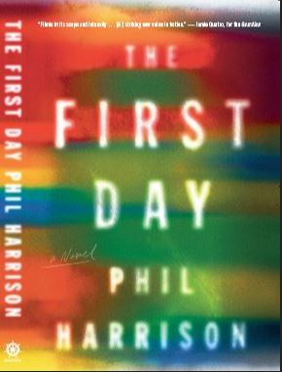
Irish Independent has called THE FIRST DAY “brilliantly written throughout...A truly excellent novel, on all counts...With tight, dispassionate, superbly controlled prose, Harrison channels the spirit of Don DeLillo or Camus...in an unflinching yet compassionate investigation of matters of the human heart." THE FIRST DAY is about the search to understand our origins and to free ourselves from the burdens of our early years. It's a stunning debut, meditative and compelling, incantatory, at times devastating and always mesmerizing. Phil Harrison lives in Belfast. Published by Fleet/Little, Brown in the UK.

Publication Date: October 2017

MY EX-LIFE by Stephen McCauley (Flatiron Books)
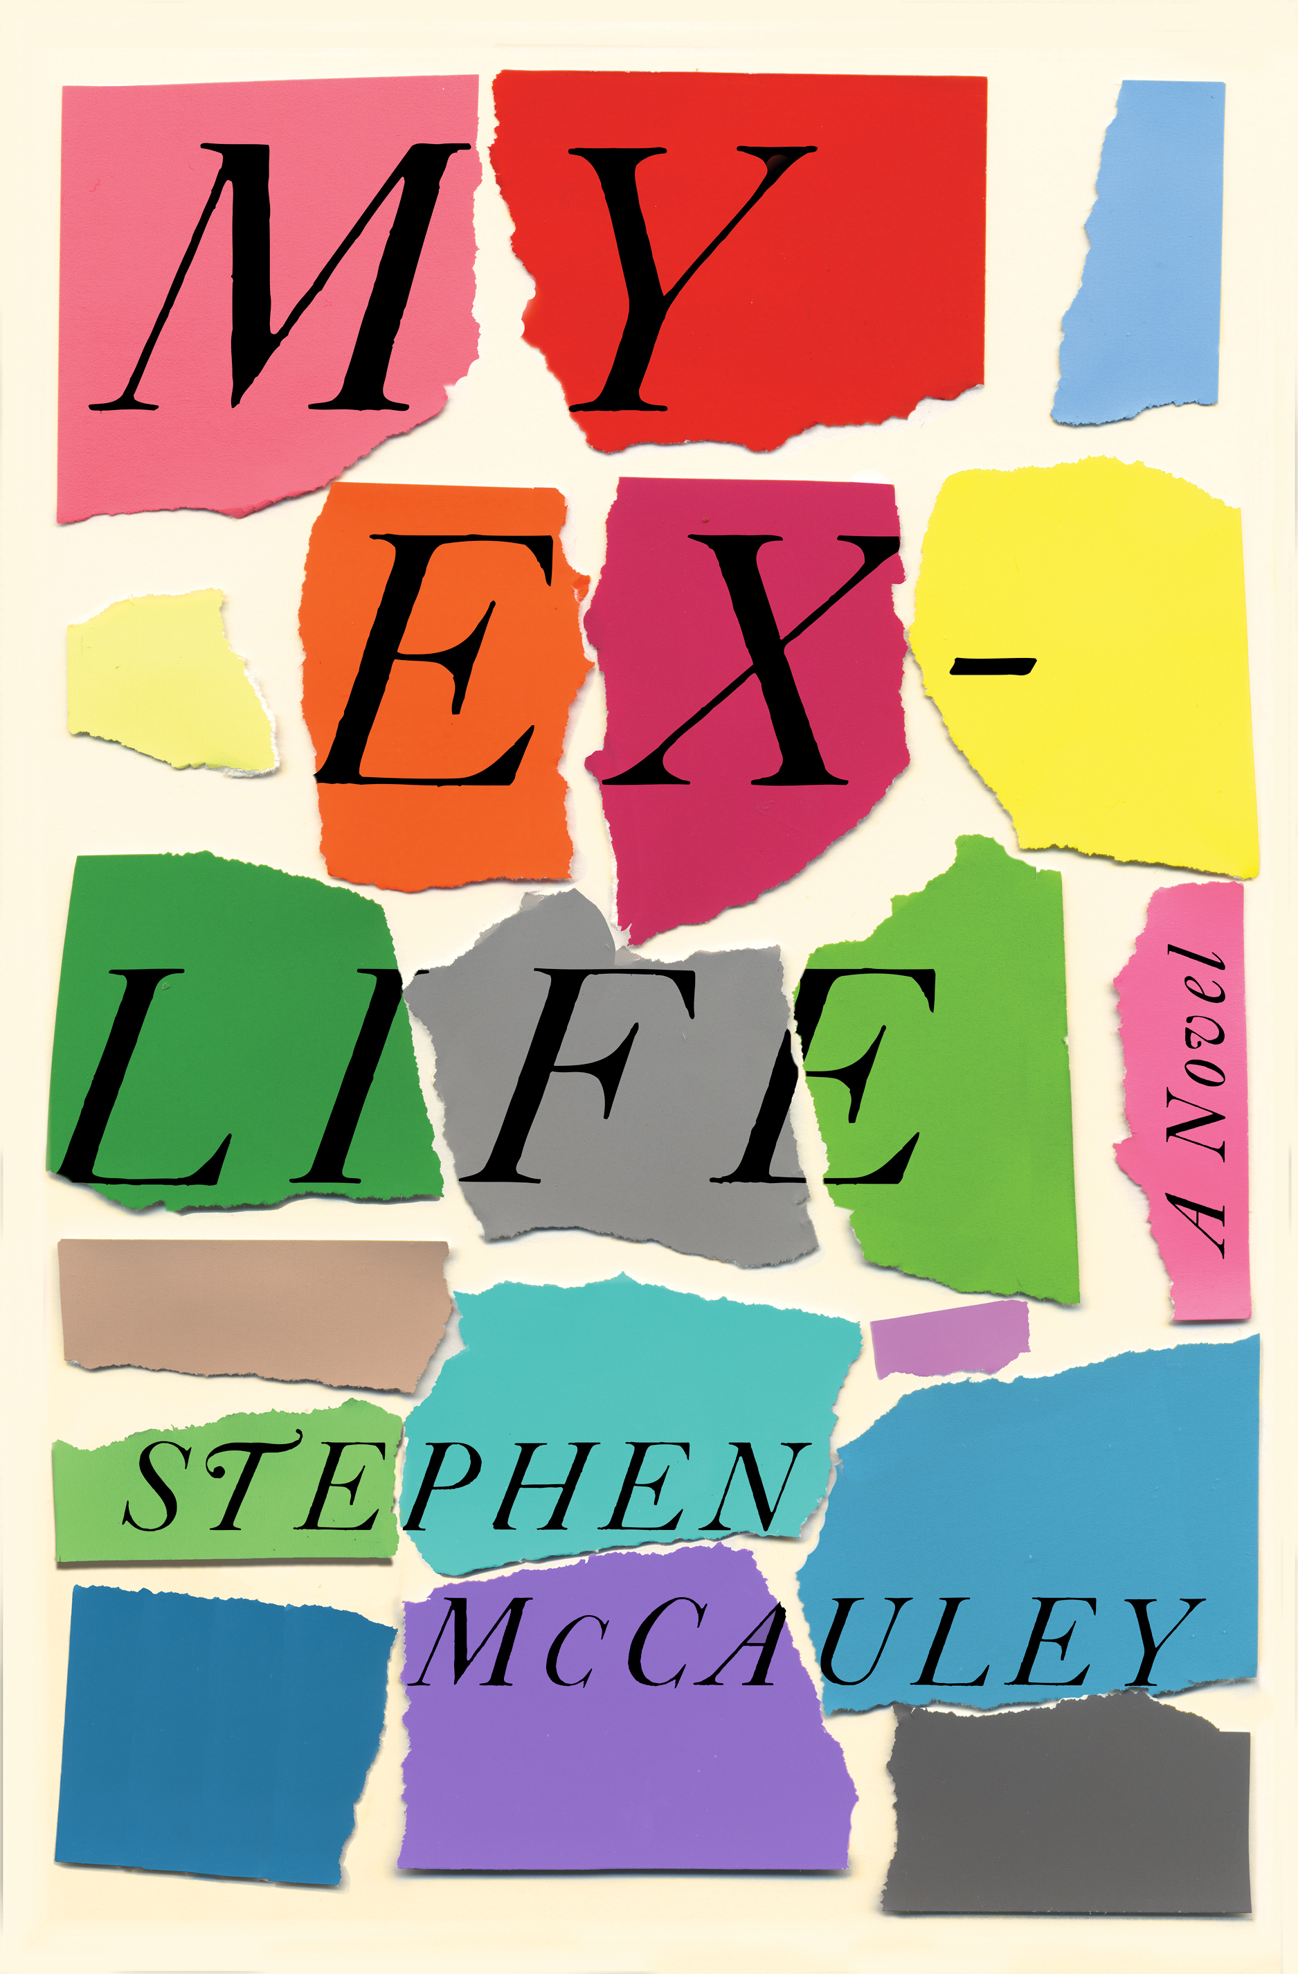
“Warm, very funny and observant, McCauley has inspired devotion in his fans since his much-loved debut 30 years ago, “The Object of My Affection”…. in his adroit and affecting new novel, “My Ex-Life,” he revisits the emotional territory of that first novel: the special closeness that may arise between a gay man and a straight woman”—San Francisco Chronicle
Tom Perrotta calls MY EX-LIFE “a wise, ruefully funny, and touching exploration of mid-life melancholy and unexpected second chances.” It tells the story of David Hedges, a man having an unusual midlife crisis. His boyfriend, Soren, has left him for an older man. His job—helping the spoiled children of San Francisco’s elite get into college—is exasperating. Across the country, Julie Fiske isn’t having a much better time herself. Into Julie’s life comes David, who happens to be Julie’s first husband. This is either a (re)match made in heaven or a disaster in the making. Many readers are calling MY EX LIFE his best book yet.

Foreign rights sold: Laffont/French
TV rights optioned by John Wells Productions

Publication Date: May 2018

WHAT TO READ AND WHY: ESSAYS by Francine Prose (HarperCollins)
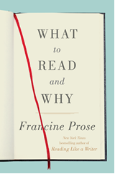
It’s been twelve years since Francine Prose’s best-selling collection READING LIKE A WRITER (2006). She’s back with a new collection of essays and reviews on reading, writing, and the art of literature. These essays look at classic works, contemporary bestsellers, cult classics, and hidden masterpieces. From Roberto Bolano to Alice Munro to Karl Ove Knausgaard and George Eliot, this collection is a wonderful exploration into what makes these writers worth reading and the art of their writing.

Publication date: July 2018

Foreign rights sold to: ThinKingdom Media Group in China

LAKE SUCCESS by Gary Shteyngart (Random House)
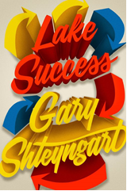
“A mature blending of the author’s signature wit and melancholy, Lake Success feels timely but not fleeting.”
– Ron Charles, The Washington Post
“…the fuel and oxygen of immigrant literature — movement, exile, nostalgia, cultural disorientation — are nevertheless what fire the pistons of this trenchant and panoramic novel” - Jonathan Miles, NYTBR

Already a bestseller only weeks after publishing. “In LAKE SUCCESS, Gary Shteyngart hears America perfectly,” writes Richard Ford. Elizabeth Gilbert calls it “stupendous.” Narcissistic and self-deluded hedge fund manager Barry Cohen oversees $2.4 billion in assets. Deeply stressed by an SEC investigation and by his 3 year-old-son’s diagnosis of autism, he flees New York on a Greyhound bus in search of a simpler, more romantic life with his old college sweetheart. How an imperfect character navigates the Shteyngartian chaos of his own making is the heart of this biting, brilliant, emotionally resonant novel: “exactly what America feels like right this minute (Elizabeth Gilbert).”

Foreign rights sold: Hamish Hamilton/UK, Penguin Verlag/German Todavia/Portuguese (Brazil), Guanda/Italian, Editions de l’Olivier/France, Balto Beidybas Namai/Lithuania

Publication Date: September 2018

PIGS by Johanna Stoberock (Red Hen Press)
Finalist for the Calvino Prize judged by Jonathan Lethem, PIGS tells the story of four children living on an island that is the repository for the world’s garbage. Garbage arrives, the children sort it, and then feed it to a herd of pigs. The pigs are beautiful, but fierce, with sharp teeth and insatiable appetites, and they will eat anything—even human flesh. When a boy washes ashore in a barrel, the children must decide what to do with him: is he more of the world’s detritus, meant to be fed to the pigs, or is he one of them? Combining elements of magical realism and suspense, this literary novel explores questions about community, environmental responsibility, and the possibility of innocence.

Publication Date: April 2019

